Binary Tree Child Identification
Introduction
A Binary Tree Child Identification System using C++ is a program designed to identify the child nodes of a specified node in a binary tree. A binary tree is a non-linear data structure in which each node can have a maximum of two children: a left child and a right child.
The program searches for a specified node in the binary tree and checks whether it has a left child, a right child, both children, or no children. If the specified node is not present in the tree, the program displays an appropriate message. This project helps in understanding binary tree structures, pointers, recursion, and tree traversal techniques in C++.

Problem statement
Write a C++ program to create a binary tree and identify the children of a specified node. The program should search for the given node and determine whether it has a left child, a right child, both children, or no children. If the specified node does not exist in the binary tree, the program should display a suitable message.
Algorithm
- Start the program.
- Create a binary tree with predefined nodes.
- Accept the value of the node to be checked from the user.
- Search for the specified node in the binary tree.
- If the node is not found, display “Node not found in the tree.”
- If the node is found, check its left and right pointers.
- If both pointers are not NULL, display Both children.
- If only the left pointer is not NULL, display Left child only.
- If only the right pointer is not NULL, display Right child only.
- If both pointers are NULL, display No children (leaf node).
- Stop the program.

Flowchart:-

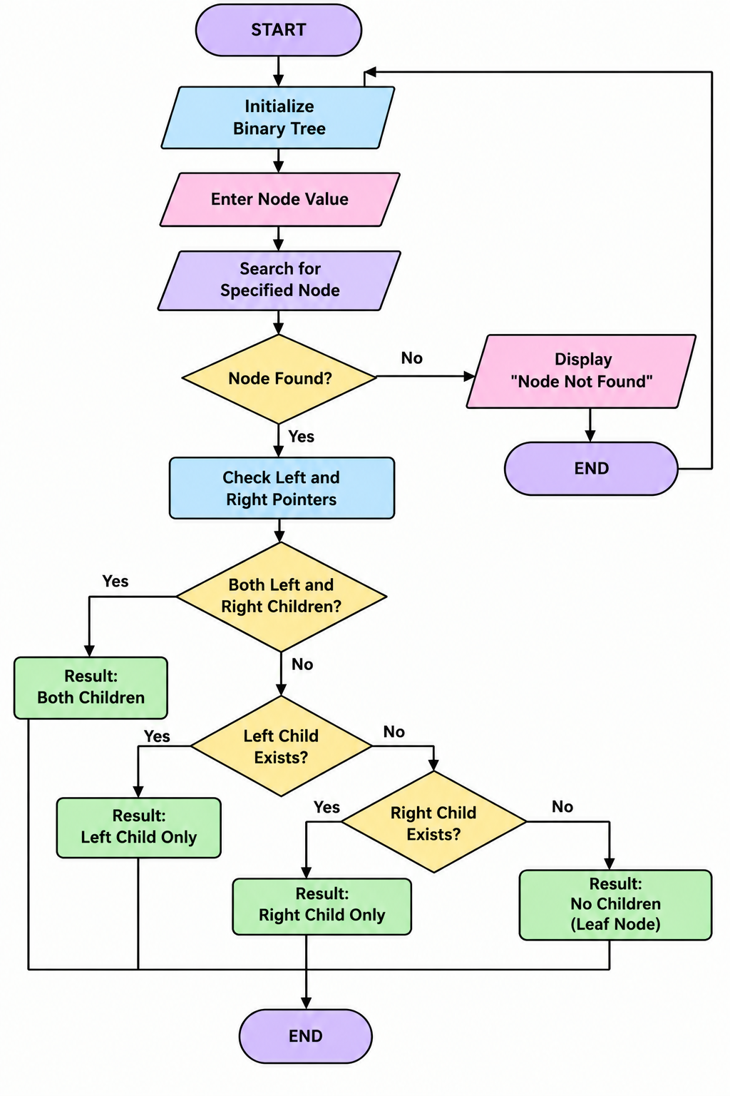
Conclusion
The Binary Tree Child Identification System was successfully implemented using C++. The program identifies whether a specified node has a left child, a right child, both children, or no children. It also handles the case where the requested node is not found in the tree. This project provides practical knowledge of binary trees, pointers, recursion, and searching operations in data structures.

